- Write a command to check our windows version.
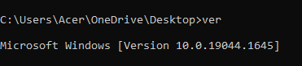

- Show the current date of your system using the command.
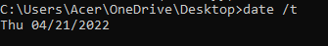

- Create the directory date. Within that directory create a text file to show the current system date.
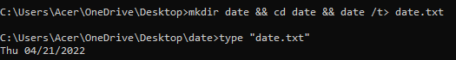

- Show the system information using the command.
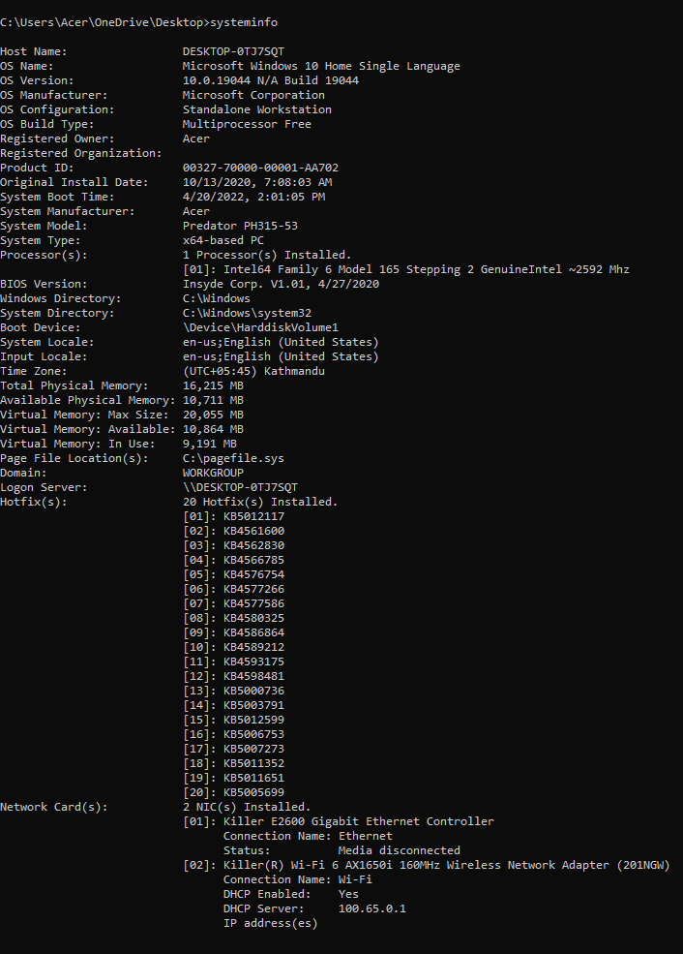
- Create the directory called systemInfo and create the file name systemInfo.txt. In that file all your system information should be auto generated using the command.
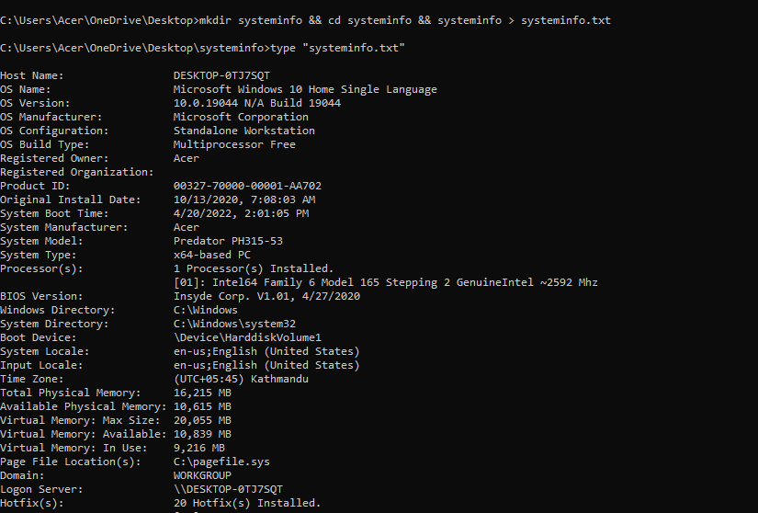

- Launch the systeminfo.txt using notepad using the command.
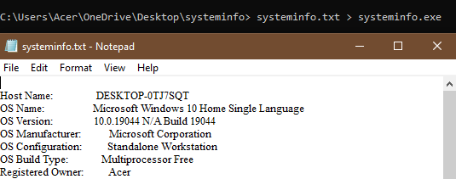

- Briefly explain about the Ping, getmac, ipconfig, powercfg command.
ping: The ping command is a Command Prompt command that is used to see if a source computer can communicate with a specific destination computer.
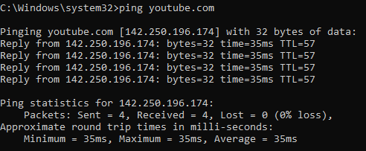

getmac: The getmac is a Windows command that displays the Media Access Control (MAC) addresses for all of the computer's network adapters.
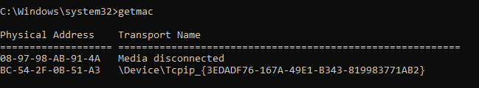

ipconfig: (Configuration of the Internet Protocol) The IP address assigned to the system is shown and managed using this command line utility.
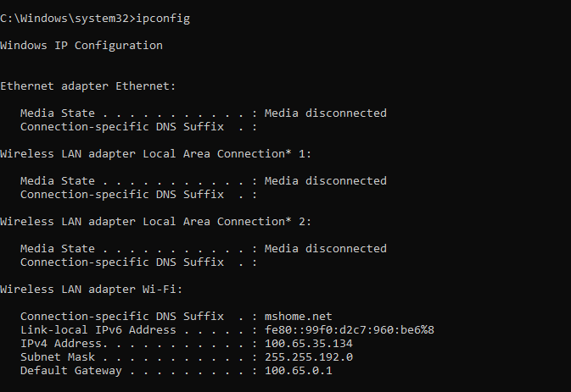

powercfg: Powercfg.exe is a command-line application that lets you control all customisable power system settings, including hardware-specific options not available through the Control Panel.
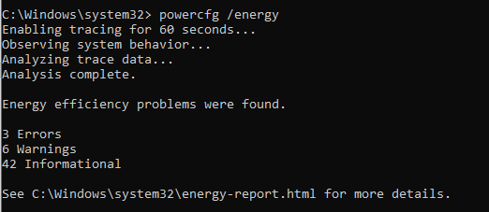

- Ping the google domain and paste the screenshot.
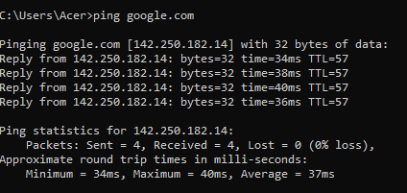

- Show the Ip address of your device.
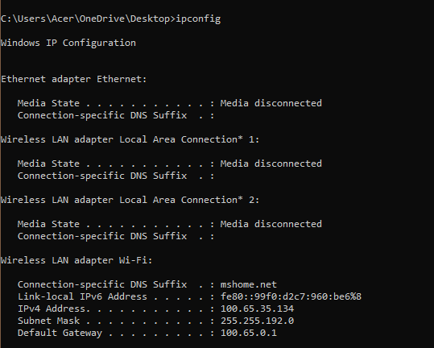

- What is the use of the FC command?
FC, or file comparison, is a command-line tool for comparing the contents of text or files. It supports both ASCII and Unicode text.

- Create the directory called difference. In that directory create two files File1.txt and File2.txt. Add contents in 2 files and perform the ascii comparison of these 2 files.
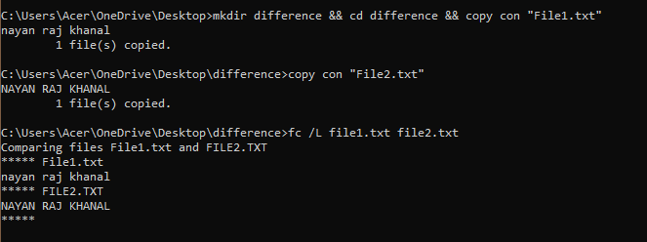

- Generate the power efficiency diagnostics report using the command.


- What does the CHKDSK do?
CHKDSK checks the file system of a volume for logical and physical errors. If used without parameters, chkdsk displays only the status of the volume and does not fix any errors. If used with the /f, /r, /x, or /b parameters, it fixes errors on the volume.

- Use the command in no.13 to check your disk space and repair any problem if it exists
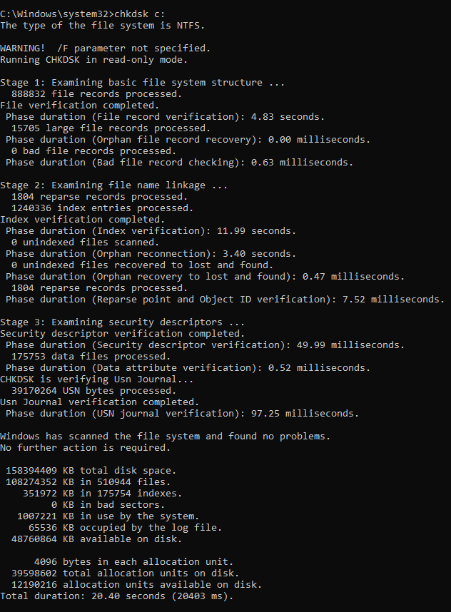

- Explain doskey /history command.
Doskey/History is one of the two examples of a command called Doskey, other being doskey. Doskey/History recalls previously entered command-line commands, edits command lines, and creates macros.
